**Qube DevOps Coding Challenge**

Execution of code

The code can be run using the command: python infra_code.py

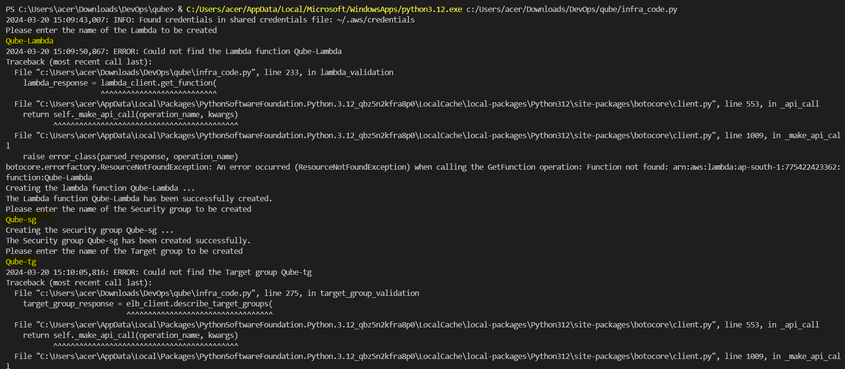

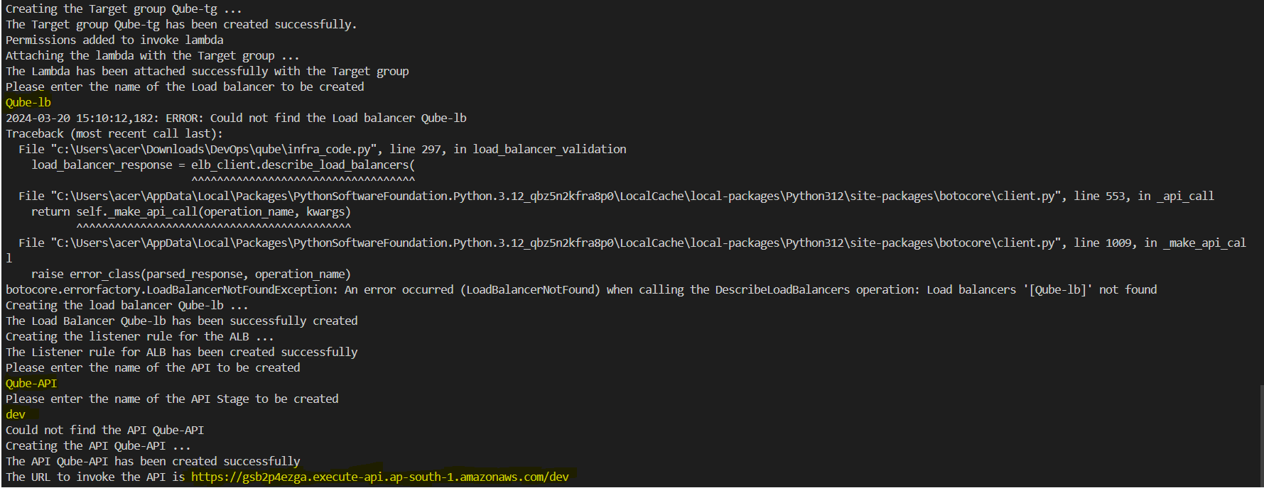

The resources that were created:

1. Lambda

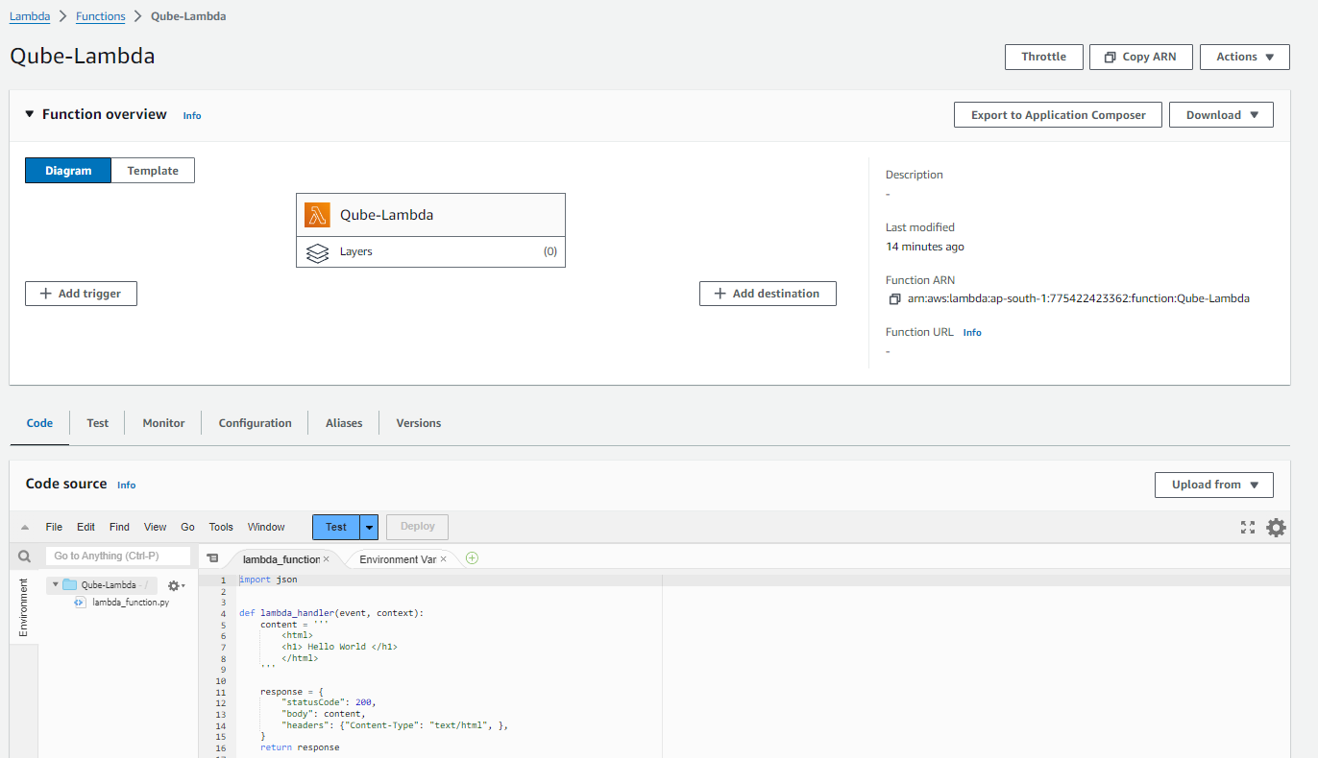

1. Security Group

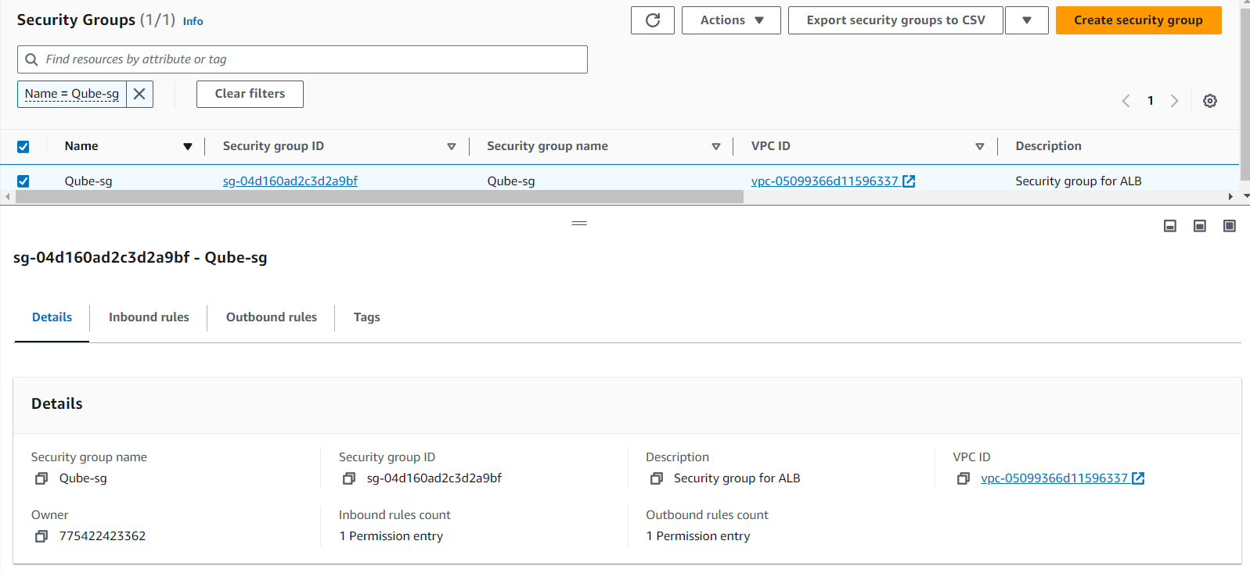

1. Target group

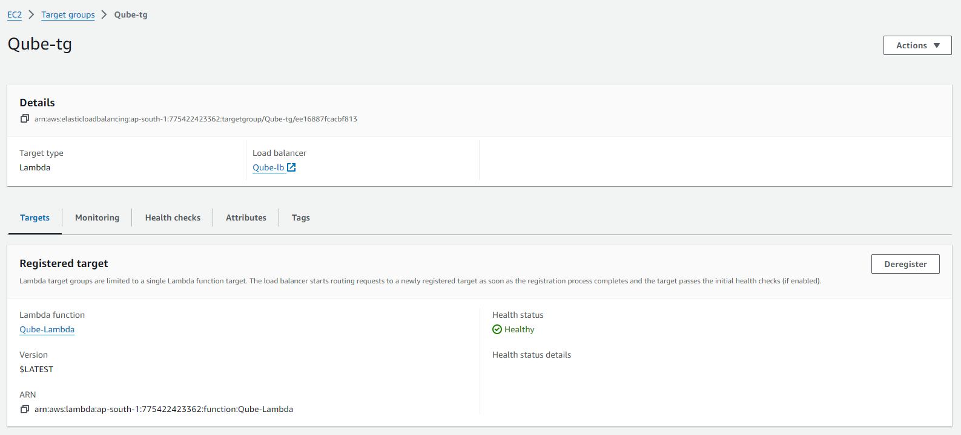

1. Load Balancer

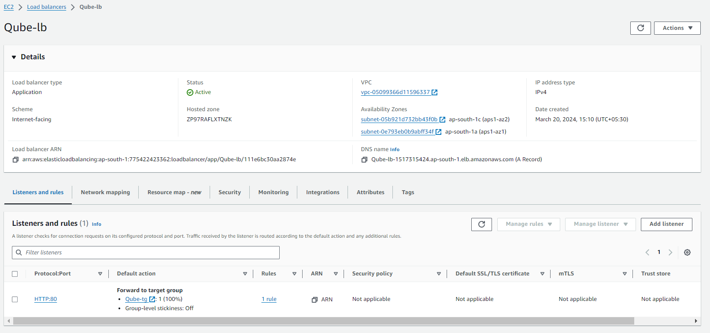

1. HTTP API

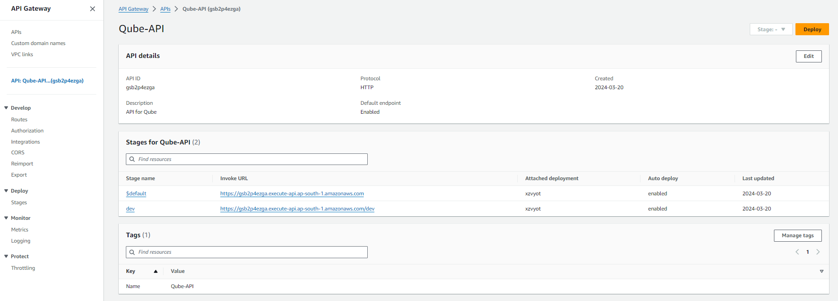

The API URL endpoint displaying “Hello World”

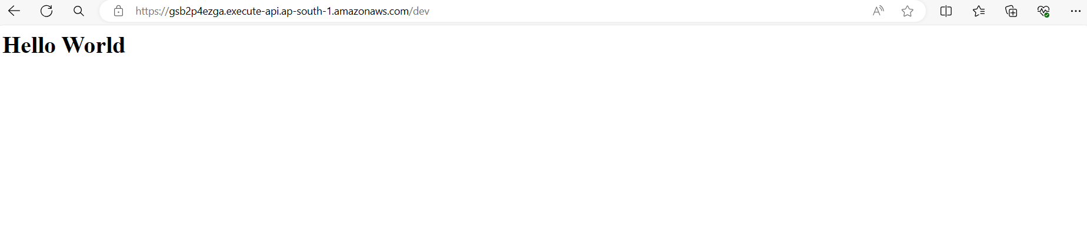

Output when we try to create the same resources again:

